**Sort command**

it will sort the words alphabetically

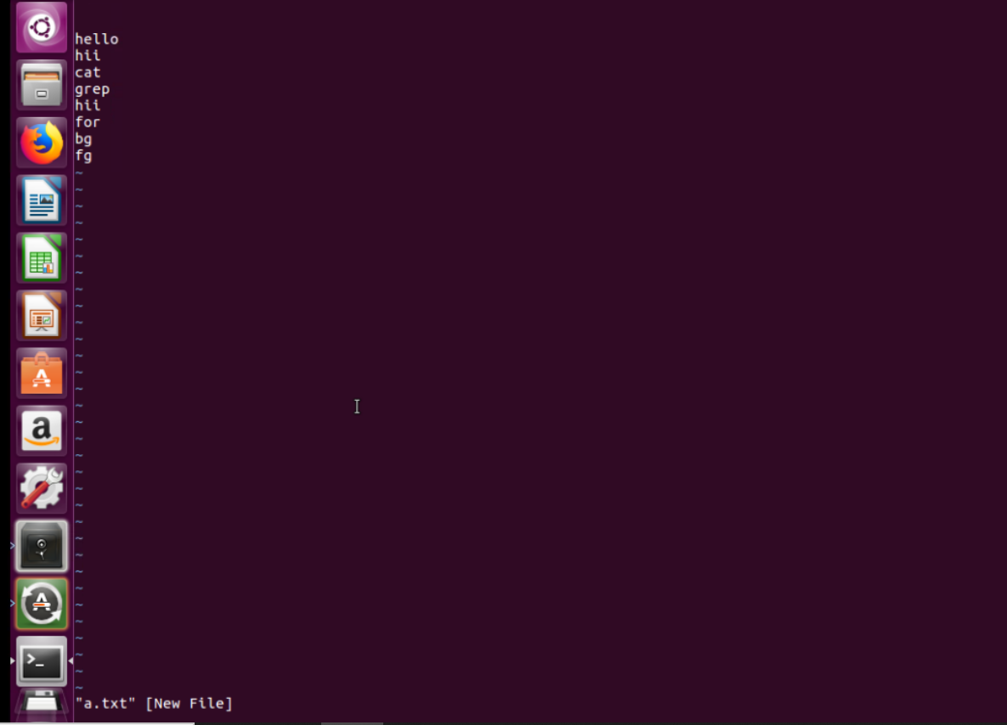

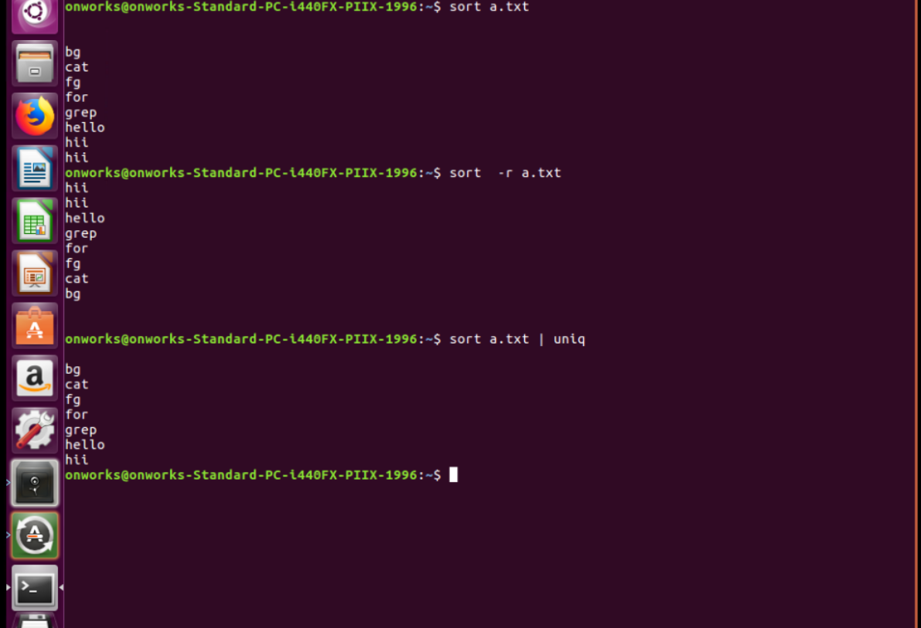

**wget and aliase**

Aliase is the temporary name given for a command

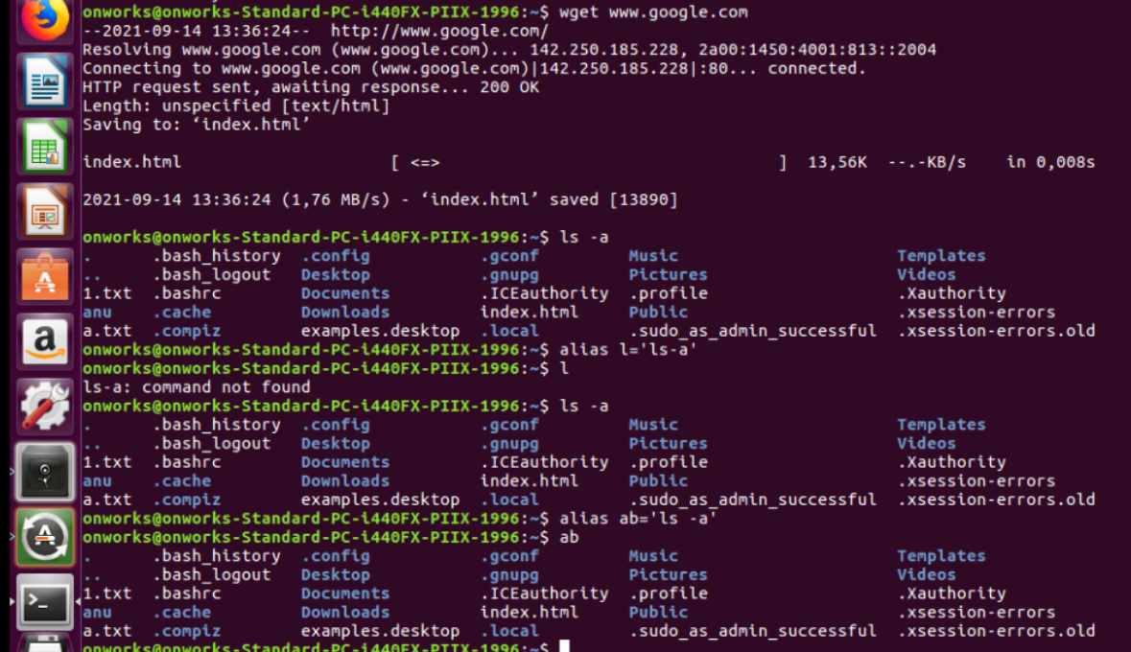

**Chmod**

For giving read, write and execute permissions to the users, group and others

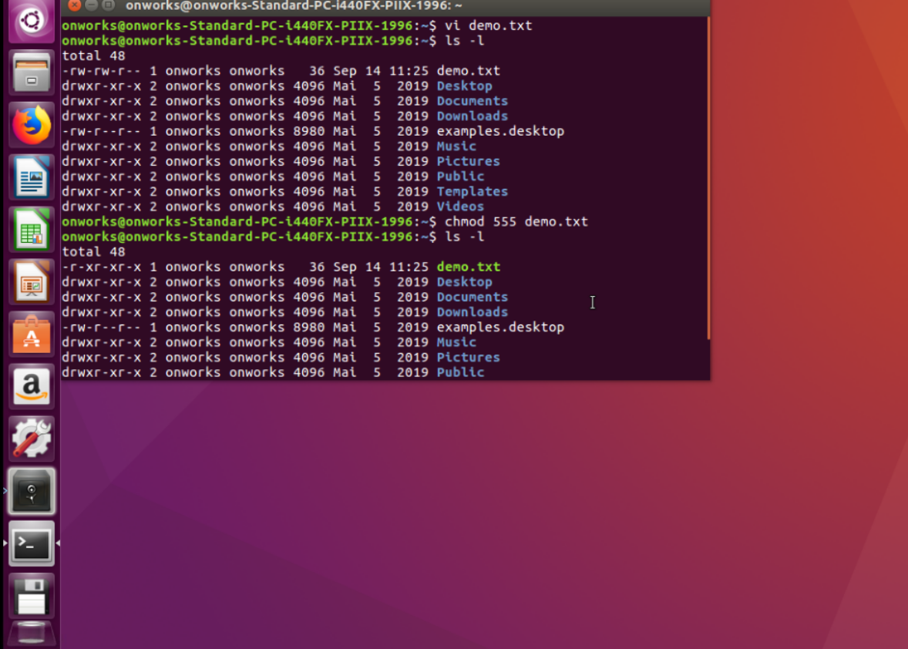

**Who, whoami**

It will display who is logged in

**History**

The history of commands which were used till now

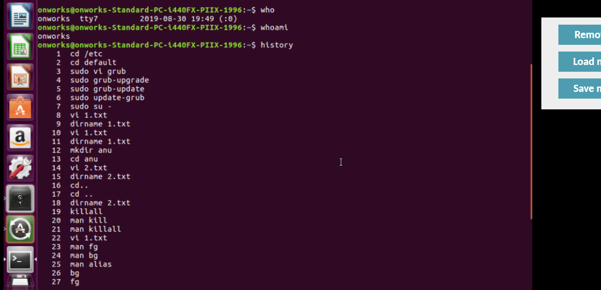

**Killall**

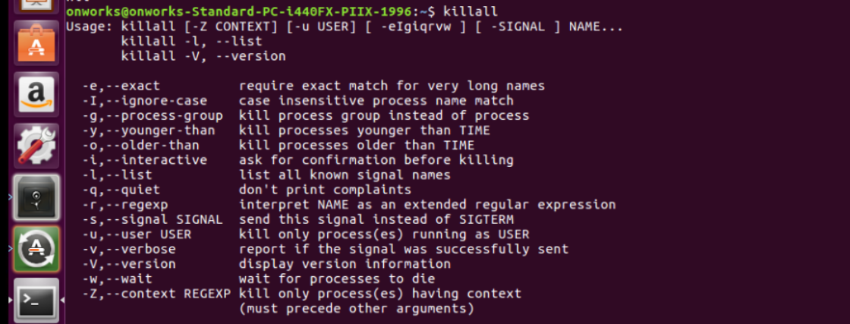

**Set number**

Numbering to a lines

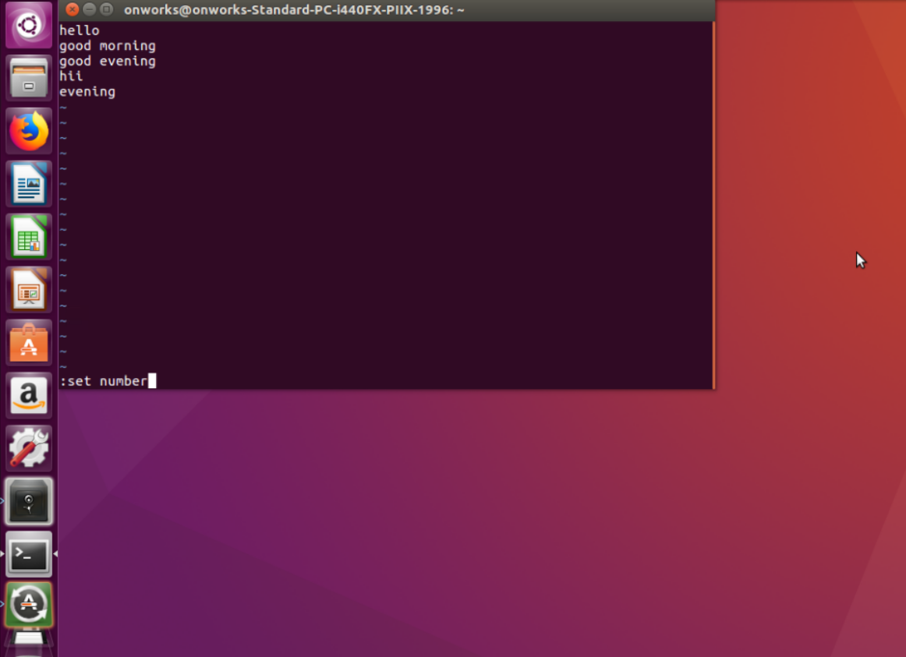

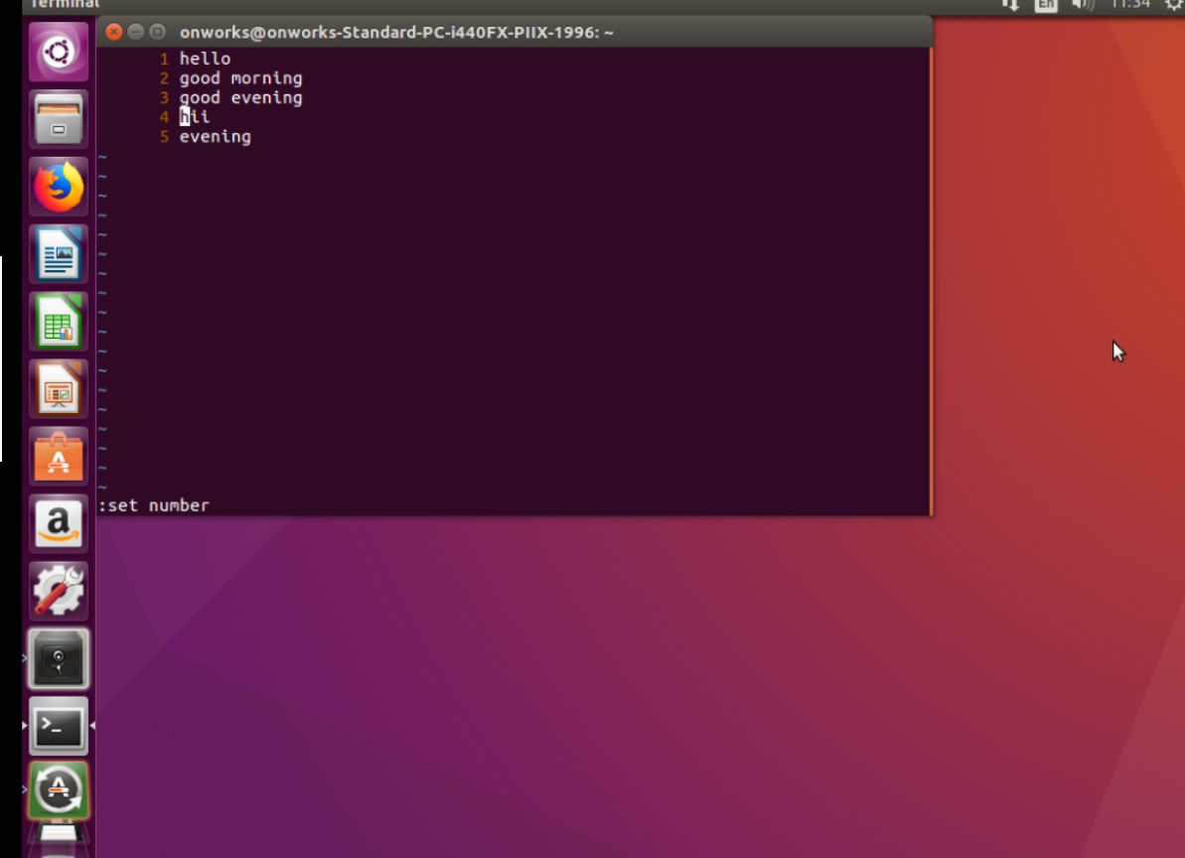

**grep, head and tail commands**

Grep is used for pattern matching

Head will display the contents from the beginning

Tail will display the contents from the end

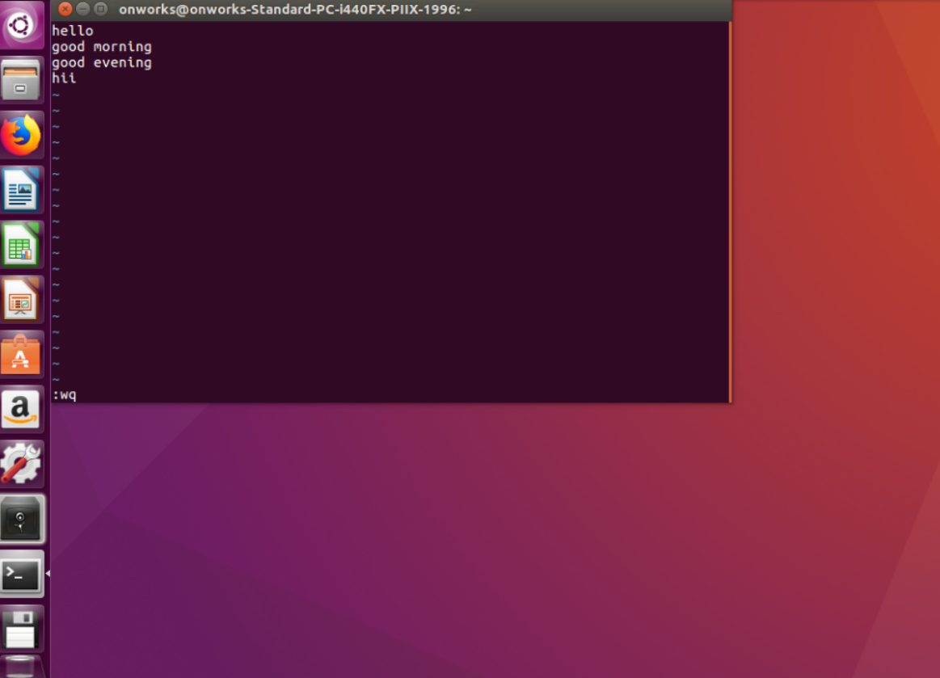

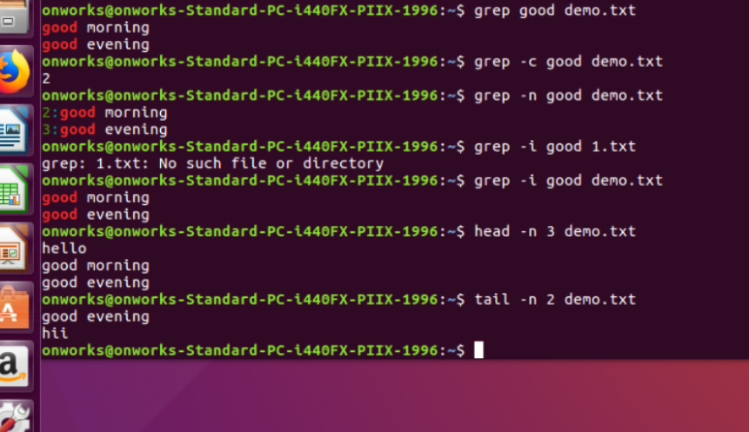

**Installing a package**

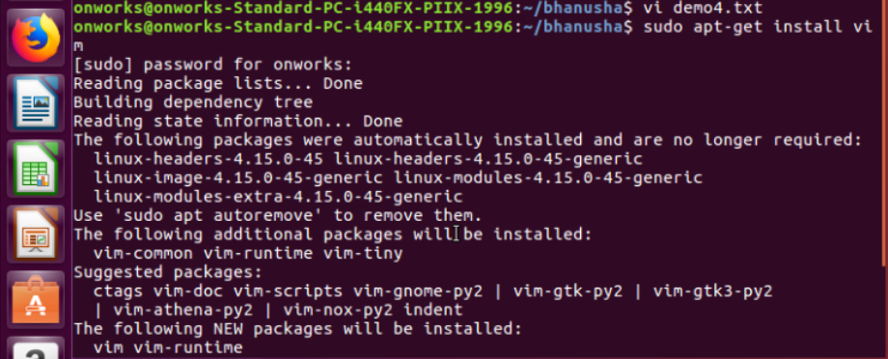

**Delete a complete word by dd**

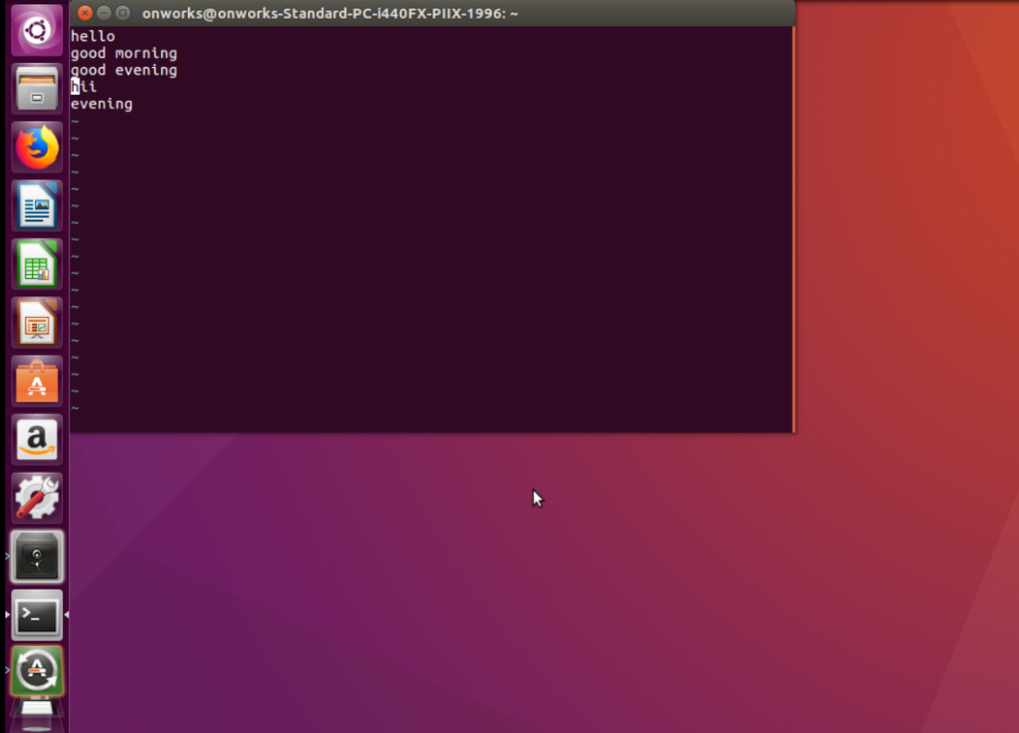

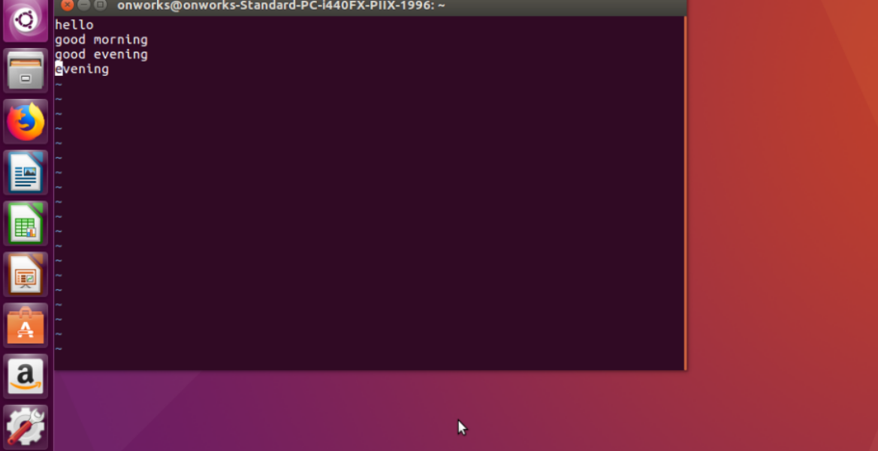

**Single character got deleted by x**

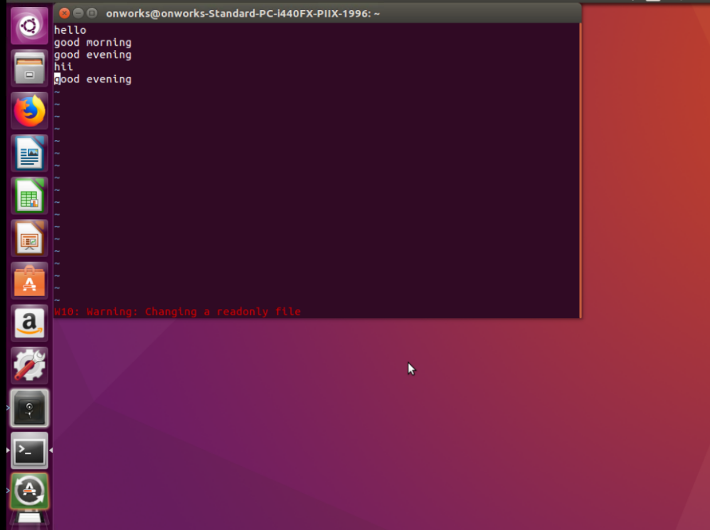

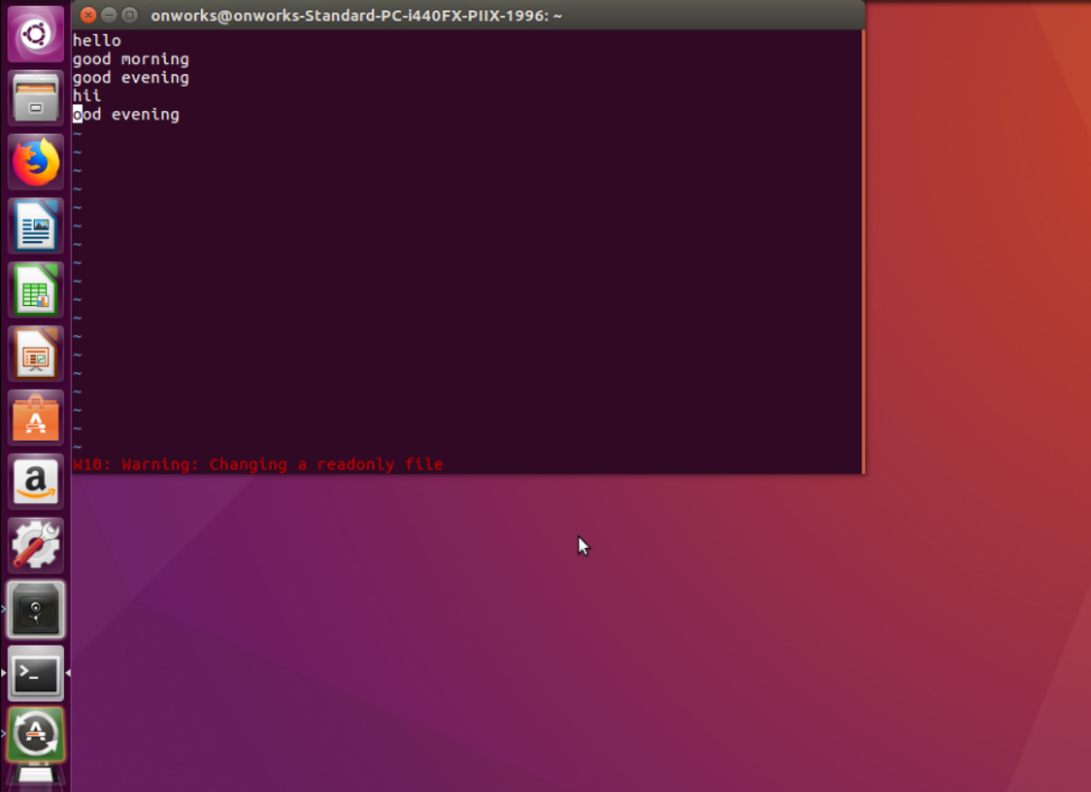

**WC**

Count the number of lines, words and bytes of memory

**Uname** – **v:** it will display the version

